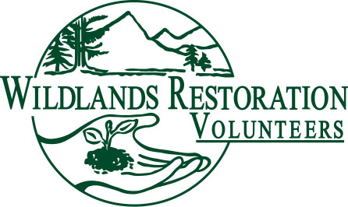

Wildlands Restoration Volunteers
Tool Manager Handbook
(a complete tooltorial)

By Owen Cooper, Star Gilmore, Ed Self, John Dawson, John Giordanengo, Barb Kirchner, & Bill Alexander
Last Revised: March, 2012

Table of Contents
- Introduction  - Project Team  - Tool Safety  - Pre-Project Activities  - Project Day Activities  - Post-Project Activities | - Appendix A: CUSSing – More on Tool Safety  - Appendix B: Tool Manager Check List  - Appendix C: Tool and Cook Team ID List & Photos

"Tool managers play a vital role in ensuring a project is successfully completed. No tools? - No project!

Tool managing requires minimum training and experience and is a great way to learn more about what goes on behind the scenes of a project. You also get to develop your leadership skills in a supportive atmosphere."

-Star Gilmore, WRV Volunteer

Why I like to be a tool manager:

From Owen Cooper, WRV Volunteer: "Well, there's the usual: feels good to volunteer, tool managing is important... Then there's the not so usual: I work all week long in front of a computer and like to get outside with WRV and work with my hands. As much as I like the community aspect of WRV, sometimes, I just like to be on my own, which is why I like tool managing. I can work hard with my hands and also have time to myself. But then, I know I'll soon be with my friends on the project. Also, I ride the bus, ride my bike and drive a compact car for environmental reasons. So driving a big rental truck is kind of a treat for me, because I know that the size of the vehicle is absolutely necessary and I don't have to feel guilty about driving a large vehicle. Also taking the truck to far out places is pretty cool. How many people can say they've driven a tool-laden Penske truck up the Rollins Pass Road to 11,000 feet?"

From Bill Alexander, WRV Volunteer: “You get the inside information on a project as part of the management team. You learn about unusual tools; what they are and how to use them. As a valued member of the project's management team, others on the project look up to you as a leader/coordinator that helps out the whole project. Usually you get to hang out a bit helping the cooks set up tents, cooking grills, etc. (It’s great to have the cooks who are making the project's excellent food - you know who you are !)
After handing out tools on the morning of a project, you get to decide what else you want to do until folks return near the end of a project day; either
Join a crew that is doing something I especially like to do; join a crew doing something I especially want to learn;
sometimes just goof off reading a book, lazing in the sun, or hiking an interesting local trail;
sometimes all of the above - just for little separate parts of the volunteer working day !”

Introduction
Tool managers are important members on all WRV projects. Their duties include the collection and transport of tools from the WRV tool shed to the project site, distribution of tools to the volunteers, returning the cleaned and inventoried tools to the tool shed at the end of the project, and safety. Tool managers also work closely with the technical advisors to determine the type and quantity of tools for each project. Most of the tool manager’s contributions occur before and after the project, so their volunteer experience spans more hours than that of most volunteers. But it’s not all work and no play. During the main project hours, tool managers are free to relax and enjoy the natural settings of the project site, or if they feel energetic they may join a crew that needs an extra hand. This manual describes in detail the main duties of a tool manager and provides many helpful pieces of information that will allow any volunteer to operate effectively in this role.

WRV Project Team
Every WRV project has a leadership team. The purpose of the team is to ensure a safe, fun project that produces a high quality result. The composition of the team can vary a lot depending on the size and complexity of the project. Some small projects are so small and simple that one leader could do everything. More commonly, a project requires several roles. The most common roles include project leader, lead cook, technical advisor(s), tool manager(s), agency staff liaison, and WRV Staff Liaison. Here is a brief description of each role. More details are available from the WRV staff.
Project Leader (PL): Oversees all aspects of the planning and execution of the project. A good PL motivates and empowers the rest of her/his team to accomplish the needs of the project. The PL looks ahead. They have the big picture. The project leader works closely with WRV staff and the agency staff liaison to ensure alignment of purpose and adherence to agency rules and regulations.

Agency Staff Liaison (ASL): Usually, this is an employee of the land management agency partner. As the legally bound public land manager, the ASL has ultimate decision power over any activities conducted on public land. The ASL represents the needs of the land management agency, and may or may not have full understanding of the capabilities and limitations of WRV. The ASL informs WRV of all rules and regulations that apply to our involvement. The tool manager may coordinate with the ASL to borrow tools from the agency.

WRV Staff Liaison (WSL): Ensures that the project terms and goals adhere to any pertinent legal, regulatory, or financial requirements. Any sub-contracted services, materials acquisition, or other financial matters are negotiated and administered by WRV staff. WRV staff usually handles much of the volunteer recruitment, press coverage, and administer volunteer registrations. A WSL will attend most projects and may help with volunteer registration, WRV merchandise, and memberships.

Tool Manager (TM): Medium to large scale projects have one or more designated tool managers, who oversee tools for the project. The introduction to this handbook summarizes the TM role, and the remainder of the document provides more detail.

Technical Advisor (TA): Fulfills a critical role, acting as a technical bridge between WRV and the land management agency. The TA translates the agency’s desired work plan into a scope and format that works for a group of volunteers, and effectively communicates the technical needs of the project to the volunteer crew leaders. The TA creates technical crew leader notes for the project and coordinates with the tool manager to create a tool list for the project.

Lead Cook: Any project that involves the serving of food or an overnight camp out will have a cook crew. This team handles most aspects of the project that are not directly related to the project work. This team plans meals, purchases food, prepares and serves meals. They set up the camp and pack it up at the end of the project, usually with the help of the TMs. This team has a lead person (lead cook), assistant cooks, and a cadre of volunteers focused on camp logistics.

Crew Leader (CL): All projects have one or more (possibly many) crew leaders. Technically, they are not part of the project team, which organizes things in advance of the project event. However, during the project, crew leaders are critical to project success. They directly supervise the work of regular, and potentially unskilled, volunteers. Involvement of crew leaders in a project usually begins with the Crew Leader Orientation session during the week prior to the project event.

Tool Safety
At any WRV project, safety is always our number one concern, followed shortly by fun, community, and education. And, yes, of course, getting work done is important too, but lower on the priority list. It’s interesting how this order of priorities leads to very productive projects!

Here are some basic safety tips for tool managers. Appendix A provides more tool safety information and will teach you how to CUSS!

- When loading tools into the truck, the heaviest items should be placed towards the front of the truck and as low as possible. Bulky and more lightweight items should be placed near the back of the truck.
- If several people are loading and unloading tools, it’s helpful to set up a “bucket-brigade” line to pass the tools so you don’t have to cross each other’s path and risk whacking each other with tools. It’s helpful to have one person in the truck, “directing” the loading operation, and sorting and organizing the tools, since the truck is a confined space.
- Lift heavy items, especially full water jugs carefully to avoid back strain—“Head up, butt down.”
- Typically the tool manager will first have to unload the project direction signs, followed by volunteer registration gear, and then the cook equipment, before arriving at the actual worksite. Therefore, these items should be placed closest to the roll-up door on the truck.
- Tools and cook items will shift during transit and therefore should be stacked in such a way as to avoid movement. Extra brewery blankets can be used as padding and space fillers.
- Always open the rear truck door very slowly in case any items have fallen against the door.
- Propane tanks and filled water jugs should always be transported in secure manner so that they cannot roll/slide around inside the tool truck. Ensure that the propane tank valves and water jug caps are closed tightly.
- When returning tools to the shed, place them in their proper place but do not try to overfill the tool racks as the tools on the end of the rack can easily fall off and injure someone.

Pre-Project Activities
- Several weeks before the project, the project leader and tool manager may consult to determine if assistant tool managers are needed, and how many. Sometimes the project leader and technical advisor make determination without consulting.
- A week or so before the project, the TM should check with the WRV office to make sure a truck has been reserved, if needed. Sometimes the TM makes the reservation, often it is made by WRV staff. Our efficient WRV staff often gives us the details before we have a chance to ask.
  - We can rent a truck from Penske, a local company that gives us a discount
  - We can borrow a moving truck from a realtor in North Boulder, if it’s available when we need it.

These moving trucks are easy to drive, but if the tool manager feels uncomfortable driving the rental truck, then a driver can be recruited with assistance from the WRV staff. WRV currently rents from:
Boulder | Penske Rental  (303) 442-6481  2560 49th St  Boulder, CO 80301 | HOURS:  M-F 8:00 AM - 5:00 PM  Sat. 8:00 AM - Noon  Sun. Closed | DIRECTIONS:  Go east on Pearl, two blocks east of Foothills Parkway. Make a left on 49th, go one block north and Penske is on the right.
Ft Collins | Penske Rental  1229 East Mulberry Street  Fort Collins  (970) 472-6023 | HOURS:  Sunday: Closed  Monday - Friday 08:00AM - 05:00PM Saturday:  08:00AM - 12:00PM | DIRECTIONS:  From I25 take the Mulberry exit West. Pass Timberline then take next turn left and left again on South frontage road.

Small one-day projects (< 50-70 volunteers) or small multi-day projects (< 40 volunteers) can usually get by with a 12-foot truck. Multi-day projects with more than 40 volunteers, or single-day projects with more than 70 volunteers, will most likely need a larger 16-foot truck with a loading ramp.

Sometimes, for the smaller projects, a pickup or two can easily haul all the gear. If a tool manager or other volunteer has a pickup or van and is willing to use it to haul project gear, that can eliminate the hassle of picking up a rental truck. Compensation for gas or mileage may be available – check with WRV staff.

The tool truck should be filled up with gas upon picking the truck up. You are responsible for filling the truck up with gas upon returning the truck. You will need to pay for the gas up-front and WRV will reimburse you. Please keep the receipt! You will need to submit a reimbursement form (call the WRV office if you need one) and the receipt to the WRV office. The WRV accountant will then issue you a check as soon as possible.

- The tool manager may be asked to work with the technical advisor to identify the types and quantities of tools needed for the project and draw up a master check-out/check-in tool list for the project. Often the technical advisor just gives the tool list to the TM. If the TA does not provide a list at least a week before the project, the TM should ask for it. Tool managers should also work with the cook lead to see what cook equipment will need to be loaded into the tool truck from the cook supply shed. The lead cook pulls the supplies ahead of loading time. The TM and lead cook should agree how the cooking supplies should be staged so that the TM can easily identify what needs to be loaded. Often times the lead cook brings some of their own supplies with them and the TM loads some of the more bulky items like tables, water jugs, canopies, and stoves.

- Sometimes our land agency partners will provide some of the needed tools, especially if WRV does not have enough of certain tools for the project. The particulars of who is responsible for which tools and gear should be clarified before the project to avoid misunderstandings and surprises on project day. Sometimes the land agency partners expect the tool manager to tell them where to stage agency tools and supplies. Clarify ahead of time what agency expects.

- Sometimes tool managers are asked to attend a pre-project site visit with the project team to become familiar with the route to the project site and to identify the tool staging area, the cook area, the volunteer check-in area, and the locations where the project directional signs will be placed. This depends on the worksite location, the type of project, terrain, and other issues.
- For more technical and varied projects, the TM may get a copy of the technical notes from the TA. The notes tell how many and what kind of tool each crew will need, which is important if you are going to lay out all tools on the ground in piles customized for each crew. You may also communicate with the TA on arrival at the staging site to determine the best strategy for staging tools.
- Pick up the tool truck the day before the project and load the tools. Bring your driver’s license with you, since they will want a photocopy. If you drive to pick up the truck, get directions on the best place to leave your car from the truck rental facility. If you don’t want to leave your car overnight there are numerous creative ways to get there. Have someone drive you there (your assistant tool manager), ride your bike and throw your bike in the back of the tool truck if there is room. Make a note of how much gas is in the tank and how many miles are on the odometer when you pick up the truck, in order to verify the numbers recorded by the rental agency.
- WRV’s tools are stored at:
Boulder | U-STORE-IT  6405 Odell Pl  Boulder, CO 80301  303-530-3600 | GATE ACCESS:  6:00 am – 10:00 PM, everyday  UNITS: Shed 2137 and 2138 | DIRECTIONS:  Take Hwy 119(the diagonal) to 63rd St  Go south on 63rd to Left on Lookout to Left on Spine to Left on Odell Pl. Drive down to end of cul-de-sac. Use right hand entrance gate.
Ft Collins | Trees Water And People  633 Remington  Fort Collins | Coordinate with staff to get access to sheds | From I25 take the Mulberry exit West. Turn left on Remington St and right onto the driveway at 633. Sheds are in the back.

Arriving at Boulder storage facility with the truck, you will need the access code to gain entry to the storage facility and a key to open the locks on the tool and PSC storage units. The access code and key can be obtained from a WRV staff member and must be kept confidential. For Fort Collins, you will need a key from a WRV staff member in Fort Collins.

- Once the tool truck is loaded (see tips in the Tool Safety section) make sure you take the padlock and key from the tool shed that will be used to lock the roll-up door on the back of the truck. Anytime the truck is left unattended the roll-up door and the cabin doors must be locked. Also make sure that you have a complete inventory list of all tools and PSC equipment that was loaded into the truck. The truck should be stored in a secure location overnight.
- Most WRV projects need potable water. Sometimes it’s not available at the site, so we bring it in large water jugs that are stored in the cook shed. Be sure to allow ample time to fill water jugs if asked to do so by the lead cook. Do not fill water jugs from a garden hose as toxic materials can leach out of the hose into the water, and/or the hose can harbor harmful bacteria. Use the drinking safe RV hose located in the PSC shed. Make sure that all jugs containing potable water are labeled potable to insure that volunteers are drinking filtered water. We do not want anyone to be exposed to unfiltered water. Communicate clearly with the lead cook about this issue.
- For a one day project, the tool manager should leave home bright and early to drive to the work site, arriving well before the project. For a weekend or multi-day project, the tool truck will often (but not always) depart to the project site the afternoon before the project to help set up the base camp.

Project Activities
The project activities begin when the tool manager begins the drive to the worksite.

- The tool manager will arrive at the worksite at a time discussed with the project leader and/or technical advisor. The tool manager should allow enough time to set up any project direction signs at pre-determined locations that will guide the volunteers to the check-in site. The sign locations will be determined ahead of time by the project team. The arrival site and worksite may or may not be at the same location. In some cases the tool manager will drop off registration gear (tables, signs, coffee cambros, stove, etc.) at the volunteer check-in site, before heading to the actual worksite. Likewise, the tool manager may also drop off PSC equipment and help with the setup of the kitchen area, before heading to the worksite.

- Once at the work site, the tool manager (and assistants) unload the tools and lay them out for crews. There are two basic ways to lay out tools:
  - Lay out all tools on the ground in piles customized for each crew. This allows each crew to quickly grab their tools and get to work as soon as possible. The tool manager should coordinate with the technical advisor to determine exactly which crew leader needs which tools.
  - Lay out piles of tools sorted by type of tool (shovels here, pulaskis there, etc.), and let the crews select the tools they need.
The tool manager and technical advisor should discuss which of these two approaches makes the most sense for this project.
- After the crews have departed with their tools the tool manager may need to move surplus tools around the worksite and help replace or borrow tools when a crew is in short supply. On multi-day projects the tool manager may help fetch extra water for the campsite.
- Never leave the tool truck unlocked when unattended, or leave the keys in the truck.
- On overnight projects, the tool manager will work with the cook crew to ensure that all food items and garbage are securely stored in the truck at night to protect against bears and other animals.
- With the assistance of other volunteers, clean and load tools as they are returned to the truck. As the tools are loaded into the truck they should be inspected to make sure they are clean and dry and crossed-off the tool inventory list on the last day of the project. If some tools are missing and if there is enough time, the tool manager should try to search for the missing items.

Post-Project Activities
The post-project duties begin when the tool manager drives away from the worksite on the last day of the project.

- Be sure to take extra care to drive safely, recognize that you may be fatigued.
- Unload the tools at the tool shed, reconfirming the inventory list. Let the WRV staff know about any missing or broken items. Label and set broken tools aside in the shed.
- Put everything away cleanly and please don’t leave a mess at the tool shed. If a temporary mess is required, inform the WRV staff. It is the responsibility of the crew leaders and crew members to clean their tools at the end of the project. You can help by reminding crew leaders early and often and by providing buckets, brushes, and water in convenient and hard-to-miss places. You may want to recruit some temporary assistance to help you make sure this happens. If tools are returned dirty, it is your responsibility to clean them.
- Make sure you return the padlock and keys to their proper place in the tool shed.
- Gas up the truck to the level it was when you picked up truck, and obtain a receipt if you want WRV to reimburse you for the gas. Please sweep up the truck. Return the truck to rental agency. Make sure you remove from the truck your copy of the rental agreement and give it to the WRV staff.
PLEASE LEAVE THE SHED LOOKING JUST LIKE YOU WOULD WANT TO FIND IT

- We advise for long projects you and your PL/WSL arrange to have a volunteer meet you back at the shed to help with the un-loading process. These may be folks that worked on the project or other volunteers who are just able to help unload tools.
- How to dispose of trash, recyclables, and compostables from project: PRIOR to the project work day, determine as a team how this will be done. The lead cook has primary responsibility for making sure these items get to an appropriate location after the project. Sometimes the land agency is able to dispose of these items. In some cases, the TM may be asked to deal with one or all of these. For Boulder, you can drop off trash/recyclables at the dumpster located at the WRV office. Recyclable products can also be dropped off at Ecocycle. Go to www.ecocycle.org and find your local center tab. Then decide where to drop off the recycling. It is free at most locations, but the hours are different.
Boulder | Boulder Drop-Off Center Phone: 303-444-6634  1901 63rd Street Open 24 hours a day. | Directions: Turn North on 63rd from Arapahoe. Go over train tracks. Drop-off center immediately on your left.
Ft Collins | Drop off recycling, trash and compost in brick enclosure in parking area behind Mugs coffee lounge on the NW corner of College and Olive. | From I25 take the Mulberry exit West. Turn Right on Remington St and go two blocks. Take a left on Olive. Turn right into alley after crossing College Ave.
Compostables can be dropped off at the following locations. In some instances, the agencies have easy access to compostable bins and we suggest asking the agency you are working with if they could dispose of the compostables. Please note that maps of these locations are posted in the PSC shed.
    - Center for Hard to Recycle Materials (CHaRM) - Accepts all compostables and used cooking oil. Free of charge. Hours Mon.-Sat. (9a-4p).
Location: 5030 "old" Pearl Street, Boulder, CO 80303; (303) 444-6634.
    - Western Disposal - Accepts all food scraps (including meats, bones, and oils), most any paper product (with the exception of anything plastic coated), biodegradable flatware, cups, etc. Free of charge. Hours Mon-Sat (7a–5p).
Location: 5880 Butte Mill Rd., Boulder, CO 80301; (303) 444-5794.

- Please give any lost-and-found items to the WRV staff.
- If it was not possible to fully organize the tool shed after unloading the tools, return within the next few days to finish. It’s extremely important that you leave the tool shed just like you would expect to have found it.
- Attend the project debrief session. Also, suggest any changes, updates, or additional information needed to improve the Tool Manager Handbook and/or training.

Appendix A: CUSSing – More on Tool Safety

The following guidelines for tool safety are to be followed by all WRV project participants. While crew leaders have primary responsibility for training and supervising their crews, tool managers need to be familiar with all aspects of tool safety and how it relates to WRV projects. These guidelines are excerpted from: OSI Guide to Crew Leadership for Ecological Restoration, produced by the Outdoor Stewardship Institute (OSI). Third printing, 2011.

The basics for tool safety can be easily remembered with a 4-letter acronym:
• Carrying tools
• Using tools
• Storing tools
• Safety with tools

“C” – Carrying Tools
There are basic safety requirements for carrying tools to and from the work site. Be alert and make sure the safety guidelines are enforced throughout the day:
• Always wear gloves while carrying tools.
• Safety sheaths should be properly in place on the tool.
• Pick up a tool and feel for the balance point. The balance point is the place where there is equal weight in front of and behind your hand. Carrying a tool at the balance point results in less strain on wrist and arms. Carrying a tool vertically requires tensing the wrist and provides minimal control over movement of the tool. The best possible control over motion of the tool is obtained when it is gripped at the balance point.
• Always carry tools in hands with arms at sides. The blade or most dangerous part of the tool should point down.
• Never carry tools propped on your shoulder.
• Tools should be carried on the downhill side of the trail. This is so that the tool can be thrown clear in case of a stumble or fall.
• When it is necessary to carry tools in both hands, carry the heaviest or most dangerous tool on the downhill side.
• Maintain a safe distance between people when walking to the work site. Everyone should be an arm and a tool-length from the next person on the trail while walking. Crew members need to be responsible for maintaining the correct distance from the person immediately preceding them down the trail.
• Watch where tools are pointed at all times.
• Let the slowest crew member set the pace for the group.
• Announce “Coming through” or “Bumping by” when approaching other crews working. Stop and wait for the crew members to cease work. The person who is working has the right of way and will cease work and yield when comfortable for them to do so. “Coming through” or “bumping by” is always a request for passage and never a demand.

“U” – Using Tools
Each tool has its proper and improper methods for use. Here are some general considerations when using tools:
• Before using any tool, make sure you know what it is used for and how to use it safely.
• Before using any tool, check to make sure the handle is not loose or split. Tag all damaged tools for repair. Any tool with flagging on the handle is not safe to use.
• Adopt the proper stance for using a tool. This will save strain on your back and make the tool more effective to use.
• Establish secure footing before using tools. Be especially careful when working in wet, slippery conditions.
• Maintain a safe working distance between crew members at all times. Be sure someone else’s space is not compromised while using a tool. Do not bunch up or crowd one another. Some organizations will maintain at least a 10-foot distance between workers as a safe operating distance when using tools.
• Full “roundhouse” swings with tools are not generally acceptable unless a crew member has extensive experience with this technique. Using a tool this way can be dangerous and may cause the user to quickly tire.
• In the rare occasion a roundhouse swing is necessary, check to make sure the work site is safe and advise those people nearby that you will be swinging. Before starting to work, clear away any brush or limbs that might unexpectedly catch a swinging tool. Yell “Swinging!” before lifting the tool to work.
• Use all tools in a motion parallel to the body rather than towards the body.
• Demonstrate to the crew how to lift with the legs instead of the back—“Head up, butt down.”

“S” – Storing Tools at the Worksite
Tools are dangerous when not stored properly at the worksite; any tool is a potential risk. Here are some things to remember about tool storage:
• Concentrate all tools not currently in use in one area if possible.
• Tool sheaths, due to their small size, are easily lost and should be gathered by the crew leader.
• Store all tools on the uphill side of the work section or trail so they are not a hazard, but can be reached easily. Store them with the handles pointed down towards the trail or work section, and the sharp or business end furthest uphill.
• Store shovels with the sharp edge towards the ground.
• Never sink axes, pulaskis, picks, or similar edged tools into the ground or in stumps where they become dangerous obstacles, i.e., impalement and tripping hazards.
• The storage of rock bars requires special attention. Rock bars are heavy and have pointed tips that can severely injure someone if they slide or roll down a hillside. To store rock bars, place the tool on the ground, parallel with the contour, and preferably centered behind a tree or rock for security. They should never be stored in such a way that they can escape downslope and create a javelin-like hazard.

“S” – Safety With Tools
Carrying, using, and storing tools present different safety issues. It is important for crew leaders to emphasize tool safety at all times. Remember these tool safety tips:
• Dis-CUSS tools in the morning and re-emphasize “CUSS” all day long.
• Be careful how you carry, use, and store tools at all times. Set a good example for your crew by always being “tool safe”.
• Always use proper personal protective equipment like hardhats, gloves, and safety glasses when using tools.
• Use the right tool, the right way, for the job at hand.
• Avoid “roundhouse” swings. You could injure someone else and you increase the likelihood of a miss-stroke and hitting yourself. Roundhouse swings are very tiring and unsustainable over extended time periods.
• Tools come in a variety of sizes, shapes, and intended uses. They are all dangerous if not treated with respect.
• Misused tools can break and are a danger to future users. They also cost time and money to repair.
• Remove all broken tools from use immediately, and tag for repair before you forget and the tool is used again.
• Stay alert when others are using tools nearby.
• Do not set a tool down “just for a minute” in the wrong place. It will become a hazard.
• Safety with rock bars is very important; they are a hazard especially when stored improperly.
• Trade off on tools occasionally for relief from repetitive stresses. Repetitive stress may cause more injuries particularly towards the end of the day.
• Always “CUSS” your tools, even if you have a crew of veteran members. The refresher is helpful for everyone.
• Be thinking about the consequences of every move. When working with a rock or log, think ahead so as not to be standing in the wrong place when it moves. Be ready to toss the tool aside and jump free. Avoid cutting toward any part of your body, and watch out for your coworkers. Use skill, not brute force.
• Everyone has different levels of coordination. Some members of your crew may need to use a given tool several times before they are able to overcome their awkwardness. For others, new tools may come as second nature. Spend an appropriate amount of time training each individual to ensure safe and efficient work habits.
8. Appendix B: Tool Manager Check List

At the First Project Planning Meeting
The first project planning meeting is the ideal time to set the stage for a successful project. Here is a checklist of items to address during the meeting, or shortly thereafter.
◻ Project timeline:
- Determine how the tool manager responsibilities (i.e., truck rental, final tool list, etc.) are woven into the overall project plan.
- You should plan to attend the site visit (if necessary) to determine logistical challenges
◻ Tool list responsibility: It is the technical advisor’s responsibility to create the tool list.
Ask the PL or TA when the deadline is for a final draft of the tool list.
◻ Lead Cook needs:
- Does cook have rough idea of equipment needs, loading times, etc. at this point? (for example, “heavy” or “light” needs for cooking equipment).
- Arrange to have final cooking supply list at least a week before project date.
- Final list should include a breakdown of what will be loaded before project and unloaded after project. Cook may plan to carry equipment to the project but expect you to carry it back to the shed after the project.
- Will there be other project-day-related chores, such as filling water containers or staging materials at multiple sites? Filling and carrying several 5 gal. water jugs can take significant time.
- Inform lead cook of timeline for loading and unloading equipment. Obtain help for the critical periods.
◻ Project difficulty: Make a rough estimate of project difficulty for the TM role. This will help you to know what to expect, to plan your project day, and to decide how much additional help you might need. Things to consider are:
- Number of volunteers
- Number and variety of tools (clippers vs rock bars)
- One-day project vs two-day projects: A 1-day project can make for a long day and can actually feel more difficult than a longer project.
- Is there a WRV-sponsored party after the project: This means unloading later at night as well as carrying additional PSC supplies.
- What are plans for garbage disposal and recycling
- Drive time from shed to project site
- Are there multiple project sites? This can mean longer times for both setting out and picking up tools.
- Additional project chores: Carrying tools to crews (on a limited basis), driving to nearby gas station to pick up water or other supplies, setting up tents, etc.
- Create a plan for tool cleanup and communicate it to project team before project day: While the crews should help, you will also be involved.

Planning Meeting to Project Day
◻ Site visit: If required, please make sure to visit the site before the project in order to assess the logistical constraints and challenges.
- Be sure you know how to get to project site. WRV staff should have a set of directions.
- Find out, or decide, where to place directional signs.
- Where will tools be staged? The closer to the work site the better, but safety, security, and traffic are also important considerations.
- Create or at least double-check the tool list to see if it makes sense. For example, will rocky soil mean more rock bars might be needed? Will more small bushes mean more loppers might come in handy?)
- Learn drive times to the project and to any additional tool staging locations.
- Identify potential problems: locked gates, difficult roads, limited access to drinking water.
- Visit the location where the “kitchen” and other cook equipment will be set up. Signs and cook equipment is often the first stuff to be unloaded.
◻ Tool list: Make sure the tool list, including cook supplies, is drafted at least two weeks in advance. Work with the technical advisor(s) to make sure this is done.
◻ Tool truck: Check with WRV staff to see if truck has been rented (Penske or Stellar Properties). This should be done at least a week in advance.
◻ Tool manager project day plan: Based on the information from the project planning meeting and the site visit, make a rough plan of your project timeline. Integrate the timeline with the project’s master schedule.
- Communicate with the truck company a few days before the project to make sure you pick up the truck before they close.
- Decide when you will load the truck, whether you need help, and a safe place to park the truck if you load the night before the project. Loading time can vary from an hour ahead of volunteer arrival to 1.5 hours or more for multi-site projects or projects far away from Boulder.
- Coordinate transportation/meeting plans with your assistant TM(s) and Lead Cook, if necessary.

9. Appendix C: Tool ID List

Austin Rock Sling (2 poles and one chain/rope sling) | 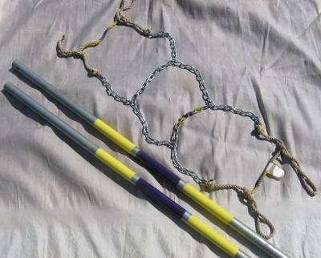 |  | Bear Fence (electric) | 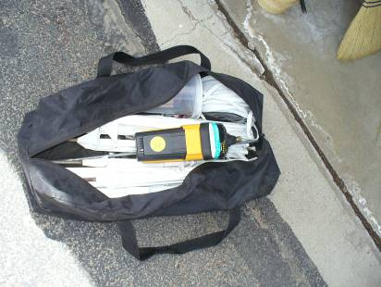
Brewery Blanket |  |  | Cambro  (2 large and 1 small) | 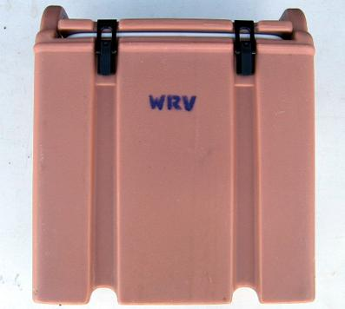
Canopy,  Outfitter wing,  for back country projects | 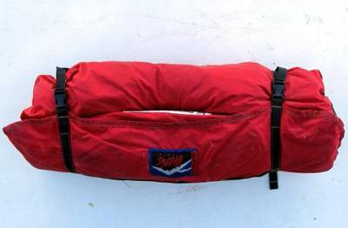 |  | Canopies (2)  (quick pitch,  10’ x 10’  and 10’ x 15’) | 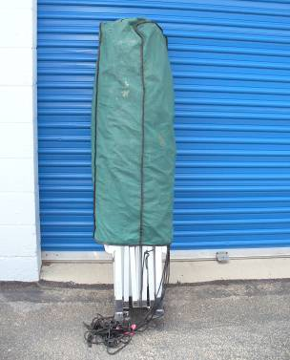
Canopy Supply Bucket | 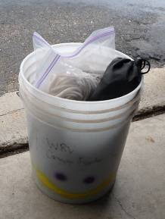 |  | Canopy Side Flaps | 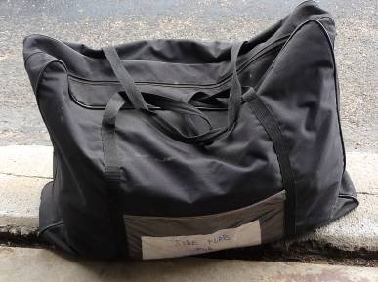
Chafing Pan | 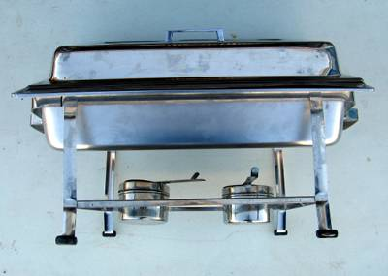 |  | Coffee Percolator | 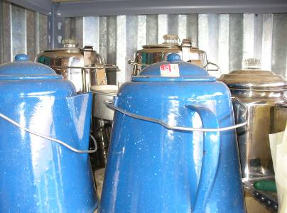
Dibble Bar  (hollow probe) | 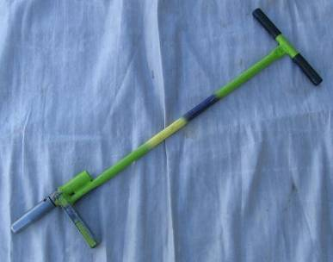 |  | Dibble Bar (Janz) | 
Gloves | 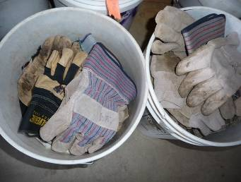 |  | Hand Drill and Bit (a.k.a. brace and bit) | 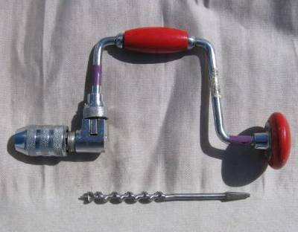
Hedge Shears | 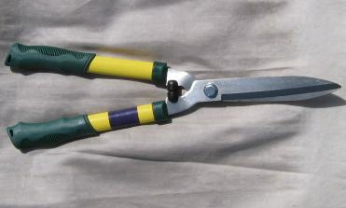 |  | Jet Stove | 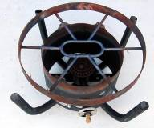
Levels | 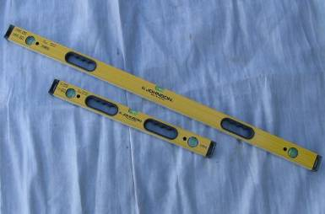 |  | Loppers | 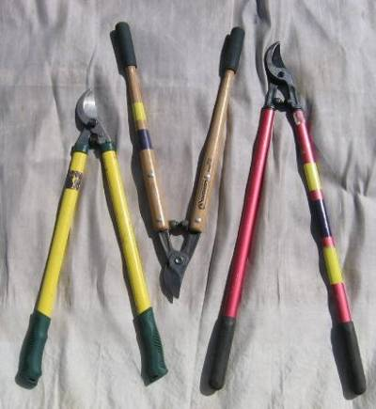
McLeod | 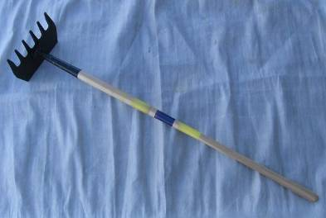 |  | Outhouse Tent | 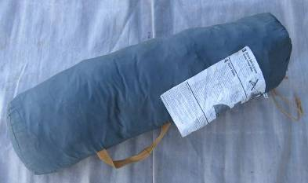
Pick Mattock,  handle and head | 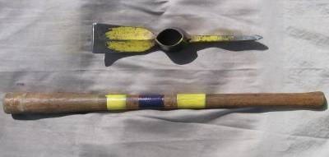 |  | Pitch Fork | 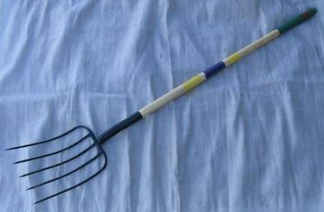
Pixie  Very similar to a pick mattock, only with a smaller head and slightly skinnier handle. | 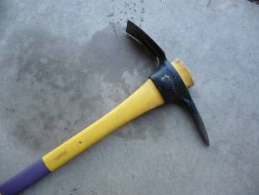 |  | Planting Bar | 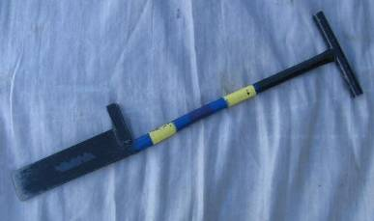
Post Hole Digger | 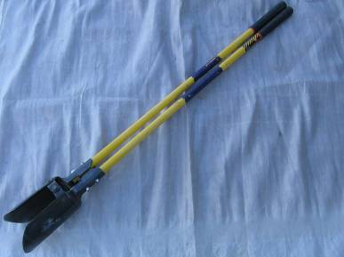 |  | Propane Tanks | 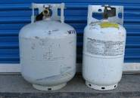
T-Post Pounder | 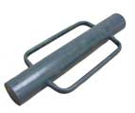
Propane Stove  (2 burners) | 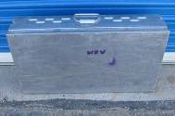 |  | Propane Stove Hoses | 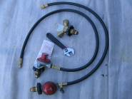
Propane Stove Accessories  (stored in a plastic tub) | 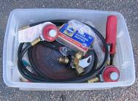 |  | Pruners  (hand by-pass) | 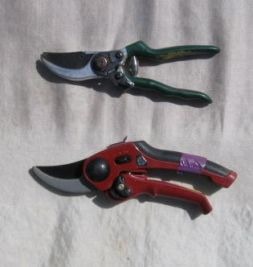
Pulaski  (bottom photo with cover) | 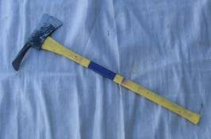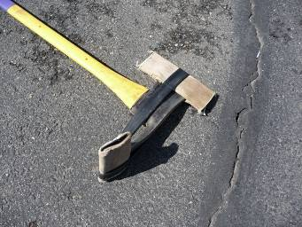 |  | Rake | 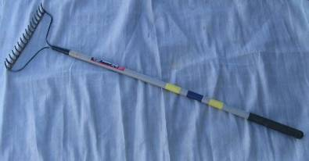
Rock Bars  (with sling) | 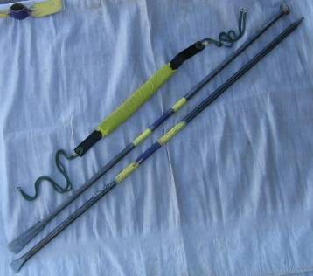 |  | Rock Chisel | 
Rocket Box | 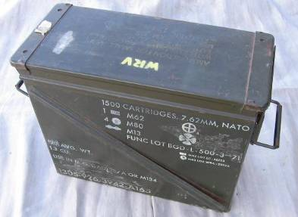 |  | Rubber Mallet | 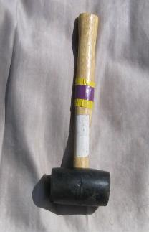
Rubber Boots | 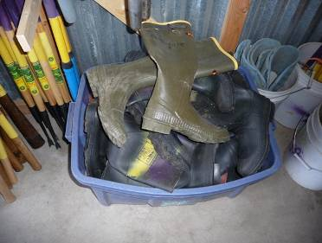
Saw, bow | 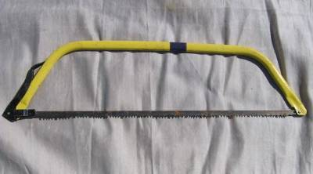 |  | Saw, hack | 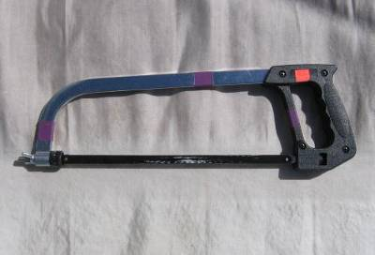
Saws, pruning  folding, with canvas covers (10” and 17”) | 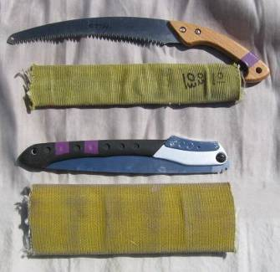 |  | Scissors  (heavy duty) | 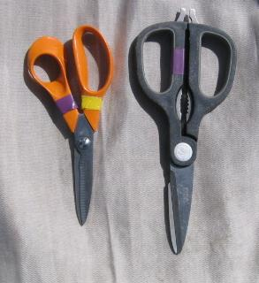
Scissors  (heavy duty) | 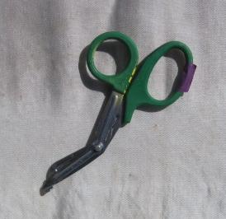 |  | Scissors  (heavy duty) | 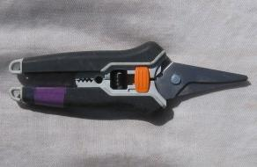
Seed Buckets |  |  | Sharp Shooter | 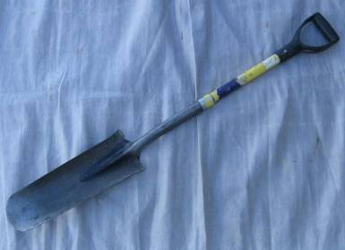
Shovel, scoop  (a.k.a. mulch shovel) |  |  | Shovel, spade  (D-handled) | 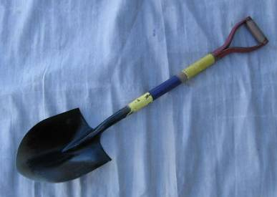
Shovels, spade and square (long handled) | 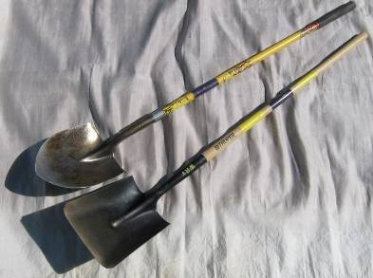 |  | Shovel, trenching | 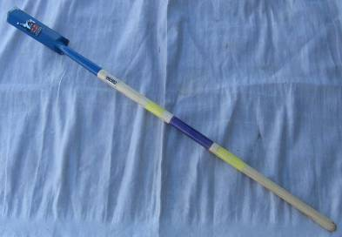
Shovel, Planting  (5” x 15”; D-handle) |  |  | Shovel, Planting  (6” x 10”) | 
Sledge Hammers  (small; 2, 3, or 4 lb) as embossed on the hammer head.  - Pruners shown for scale | 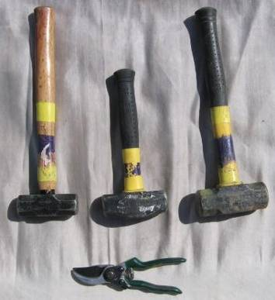 |  | Sledge Hammer  (large, 8-12 pound) | 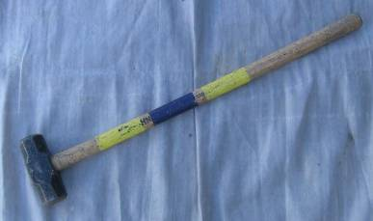
Sod Stretcher  two wood slats  two thin poles  one canvas sheet with sleeves stitched on the sides for the poles | 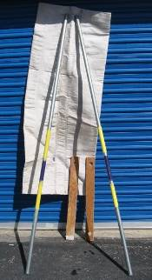 |  | Stake Puller | 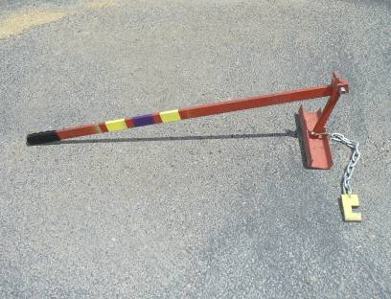
Swing Blade  (a.k.a. weed wacker) | 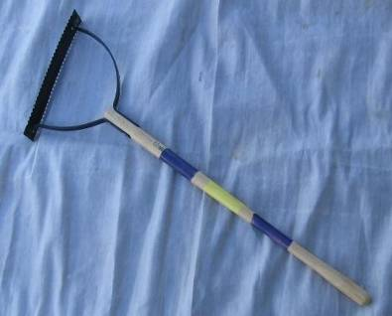 |  | Table,  portable (3’ x 3’ roll-up) | 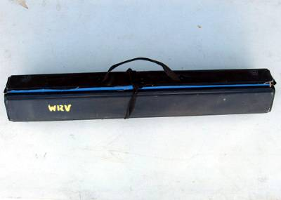
Tin Snips | 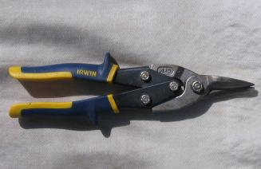 |  | Tin Snips | 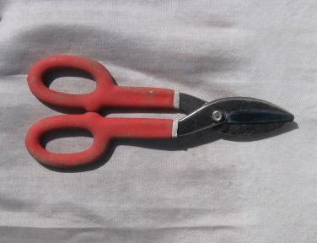
Trash Can, (collapsible),  red = trash  brown = compost green = recycling |  |  | Trowel | 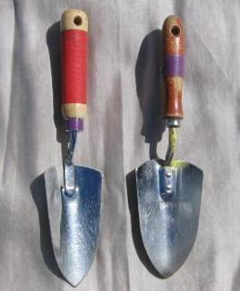
Weeder  (small, 14 inch, two-pronged) | 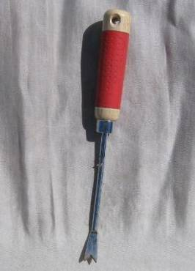 |  | Weeder  (long, two-pronged) | 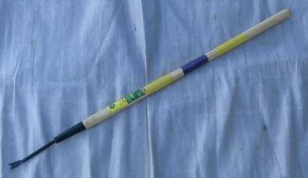
Weed Wrench | 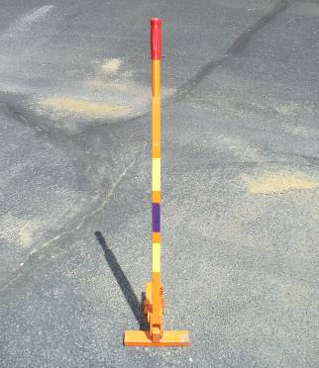 |  | Wheel Barrow | 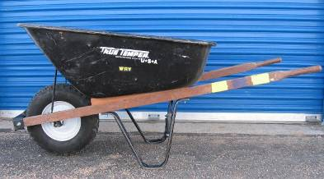
Wire Brush | 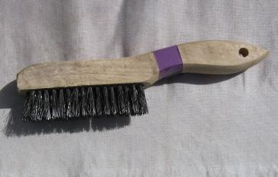 |  | WRV project direction sign | 