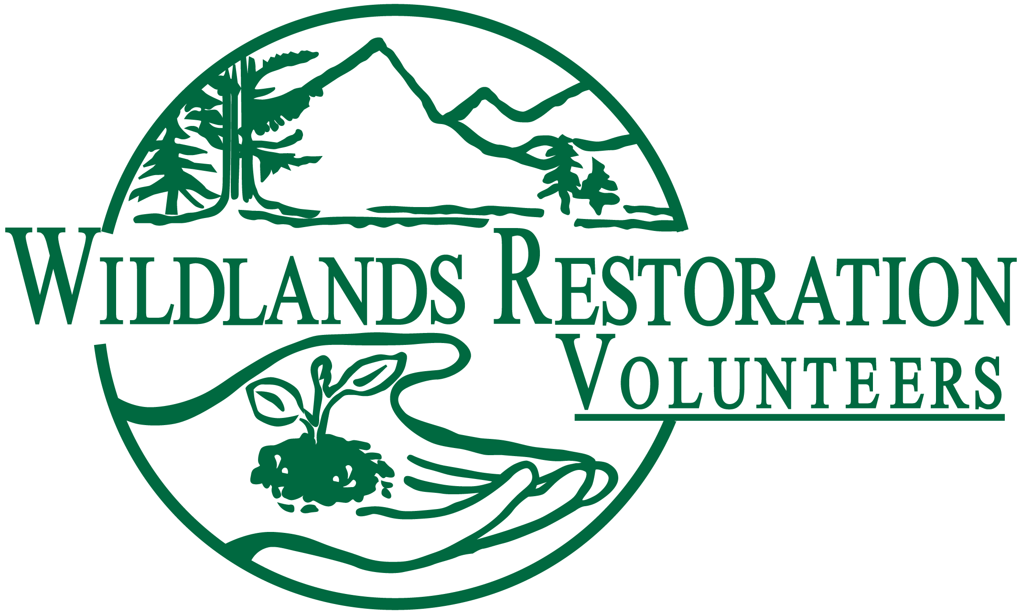
Tool Manager Collective Wisdom

The most important factors to success in a project (and fun/satisfaction in the planning team) are:

- Clear early communication
- Respect
- Flexibility

Below are “nuggets” of wisdom that apply to Tool Managers.

Tool Manager (TM) ←→ Technical Advisor (TA)

Communication
- TA and TM should talk early in planning process to clarify…
  - General expectations of who is doing what and when
  - How TM wants to be involved
    - Do they want to come to site visits?
    - Do they want to come to crew leader orientation?
    - Do they want to give input on which tools to use?
  - Process/timing for creating tool list.
  - If this project is similar to a previous one (type or location), then share sample tool lists, crew leader notes, and tool lessons learned from previous project(s).
  - Discuss whether this project warrants tool bundling or not.
- TA and TM should clarify these things in final two weeks…
  - Reconfirm the process/timing to finalize the tool list and accommodate last minute changes to expected volunteer count.
  - How/where/when will tools be staged?
  - Will tools be pre-bundled per crew or not? Bundles tend to work better when most crews are doing similar things and have predictable tool needs. Piles of each tool (for CLs to choose from) are better if work varies a lot from crew to crew, and/or if the work involves tools for which preferences tend to vary a lot.
Tool Lists
- TAs should send preliminary tool lists to TMs, at least one week before project – NOT wait until last minute to send a “perfect” list.
- If TM wants to give input on which tools to use, then they should get a tool list at least two weeks before project.
- Clear communication in final 2 weeks before project so TM knows what to expect about tool lists.
- Tool list should include 10 to 20% extra to account for tool breakage and loss, PLUS other tools that might be used. According to TMs, the extra effort to bring these tools is totally worth it to deal with unexpected contingencies, and because it may be a LONG way back to the tool shed.
- If any tools already onsite, for instance for an AmeriCorps crew, let the TM know.
- Move gloves and other personal protective equipment (PPE) from “Support” list to “Tool” list. DONE

Crew Leader Orientation and Technical Notes
- TA should always send crew leader notes to TM, including preliminary versions to give a sense of scope and logistics of project.
- Discuss tool cleaning (for end of project) both in technical notes and at crew leader orientation.

Tool Manager ←→ WRV Staff Liaison
- If this project is concurrent with another, really important for WSL to get TMs for these projects talking about how to share tools and PSC gear from both sheds.
- WRV usually automatically tries to recruit an ATM for bigger or more complex projects. The TM should feel free to ask WSL to recruit extra ATMs if needed.

