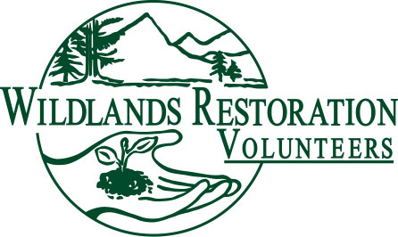

WRV Volunteer Role Description
Last Updated 10/3/08

Title: Project Support/Cook Lead

Team or Committee Affiliation: Project Team Member

Description: For a project in which the crew members will be fed, the PSC Lead is responsible for heading the team that feeds them

Objectives: To provide tasty, healthy and sufficient amounts of food for the hardworking crew members.

Responsibilities: The PSC Leader

- Supervises a PSC crew of one-six cooks that prepares meals at the project
- Assists WRV staff in recruiting support cooks
- Plans for and obtains donations of food for the project
- Plans a balanced menu for the project crew
- Creates a shopping list and buys all of the food and supplies needed
- Prepares, packs, and ensures the food and supplies are transported to the work site
- Supervises the camp kitchen setup
- Manages a safe and efficient kitchen during the project
- Supervises the camp breakdown and cleanup
- Assures the safety of the PSC crew and the food product served
- Observes other team members noting possible candidates for leadership
- Encourages candidates to get involved in leadership
- Oversees Zero-waste efforts; takes composting and recycling to drop-off sites or assigns others to do so at the end of the event

Background or qualifications: Experience planning and cooking for large groups of people is suggested. Must be organized and detail oriented.

Training / Preparation: Attend PSC training class. Helpful to have been a support cook on previous projects

Time / Place: The PSC lead usually needs to be at the camp site earlier than other crew members to transport the food and set up the camp kitchen.

Commitment: Project by project, as needed

Over-sight: The PSC lead coordinates with the project leader, WRV staff, PSC staff, and tool manager(s).

Measures of success: A successful PSC lead will see that the project crew is safely fed well, on time, within budget, and without excessive waste. And it should be yummy.

