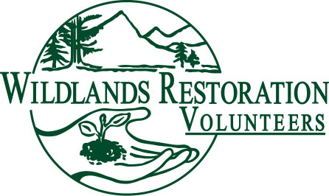
Project Debriefing Form
Updated May, 2022

Project Name: | Date of Project:
Project Leader: | Date of Debrief:
Form Filled Out By:
Agency Contact:
Attendees:
Please describe succinctly any problems and outstanding successes you encountered in the categories outlined below.

What was successful and what is one thing you would do differently?

List mentees who graduated (names, leader roles, and summary notes)

Potential New Leaders (names; recommended leadership roles; why are they good candidates?)

Examples of important information: Thoughts on how to repeat successes and ideas on how problems could have been avoided. Please type up results. Boxes below will expand as needed.

Use This Section to Record Relevant Information
Pre-Project Planning (scheduling, site visits, meetings, communications, leadership roles, etc.)

Technical (site prep, materials staging, crew leader notes, site staking and flagging, type and quality of work)

Logistical (registration table, parking, carpooling, radios, tool loading/transport/unloading/vehicles, toilets, pack animals, etc.)

Project Support/Cooking (meal planning and transport, camp setup/packup, cooking, sanitation, food storage, volunteers with special food needs, waste disposal, etc.)

Safety (injuries, near misses, bad weather, auto accidents, bystanders)

Group Communications (pre-project correspondence, welcome at beginning, mid-way talk, educational presentations, end of project wrap up and thank you, communications with general public, media coverage, etc.)

Behavioral Issues (Can also be reported in survey if not appropriate to discuss publicly)

Project Closure Checklist
Thank everyone on the Project Team. Encourage leaders to include any additional feedback via the post-project survey.
Send completed debrief form to WSL.
Give final electronic versions of all project documents to WSL (e.g. technical notes, section notes, diagrams, maps, tool list, registration form, and anything else that might be useful on a future project.
Follow up with volunteer project photographers to make sure photos are delivered to WRV staff.
Tally up hours of all volunteer team members and enter send to WSL.
Assist with collecting/ recording relevant project stats.
Debrief and evaluate with your assistant project leader, if you had one, and report results/ submit mentoring form to WRV Staff Liaison (WSL) on project.
Debrief your experience as project leader with WSL.

