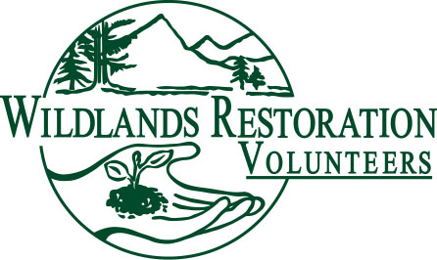
Project Application & Scout Form 2017
Agency Section (please complete this section to the best
of your ability. If you feel you can adequately complete portions
of the Scout Section on Page 2, please do so).

Project Name:
Agency Name: | Elevation:
Agency contact (name, phone, email):

Location (include property name, nearest town, and any nearby geographic features):

Category of work (e.g. wetland/riparian restoration, post-fire restoration/wildfire mitigation, trail construction/maintenance, weed management, road obliteration, etc.):
Project Goals(s), desired outcome(s):
General Project Description (i.e., a paragraph to describe this project to a volunteer or funder):

Quantitative Estimate of work needed (e.g., feet of road/trail to close, # plants to install, sq.ft. to seed/mulch, feet of stream bank to restore, acres of wetland to plant, feet of trail to maintain, acres to weed, feet of fence to build, etc.):
What is special (exciting, important, unusual) about this project?
What is the status of any outstanding permits or surveys required for this project to proceed (i.e., Threatened and Endangered Species, NEPA, Hydrology, Soils, 404 wetland permits, other)?
If SHIPO (State Historical Preservation Office) or other cultural resource compliance is required, have the relevant surveys been completed? If not, when will they be completed?
Are there any other management issues that must be addressed before restoration work can begin (e.g. closure/site protection, grazing management/fencing, land grading, user management/PR, technical assessments/designs, etc.), and who will be responsible for this work?
What is the plan to ensure long term success/protection of treatments on this project, including monitoring, weed management, watering plants, user management, etc.?
What rare, threatened, or socially important (i.e., state bird, rare plant, watchable wildlife, etc.), animal or plant species, or other significant state resources, will be benefited by this project?
Potential funding to cover WRV’s internal planning & implementation costs (please list sources and dollar amounts):
If you and/or your agency are submitting more than one project, please list how high of a priority this project is relative to the other proposed projects?

Other Remarks:

Scout Section (to be completed by Agency or WRV Scout)

Scouted By (if appropriate): | Date Scouted:
Estimated Number of Volunteer-Days to Complete Project (e.g. 50 vols for 2 days):
Explain Rationale for Estimate:
What site prep (e.g., heavy equipment work, materials staging) will be required and who is responsible for this work?
Access to worksite (distance from parking area/trailhead, river crossings, snow, etc.):
Camping issues/logistics:
Parking issues/logistics:
Other logistical challenges:
What significant safety concerns exist (tree dead-fall area, loose rocks on steep slopes, poisonous plants or animals, etc.):
Permit Issues. Double check the status of any permit issues and surveys that may be required before work begins (NEPA, T&E species, Hydrology, Soils, other?).
What historical/cultural significance does the site have? Double check the status of relevant cultural surveys that may be required before work begins (i.e. State Historical Preservation Office).
What opportunities exist for partnership with other organizations (e.g., land management agencies, conservation groups, user groups, funders, etc.)?
What is the outreach and educational potential of this project (e.g. educate community about important conservation issue, high visibility project, recruit new volunteer population)?
What extracurricular enticements are available for volunteers, particularly for multi-day projects (e.g. fishing, hiking, wildlife tours, rafting, showers, music, etc.)?
Is WRV the best fit for this project? If not, who is (contractor, VOC, CFI, agency, etc.)?
What is the best time of year to implement project (snowpack, high water, plant phenology, etc.)? Does agency have any black-out dates (wildlife closures, funding cycles, etc.)?

Can your agency provide a project medic (what level of certification)?
Other Remarks:

