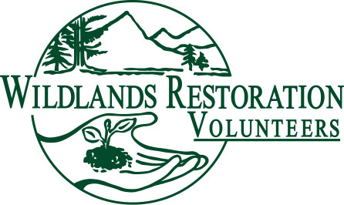
WRV Volunteer Role Description

Title: Crew leader

Team or Committee Affiliation: Project team

Description: Crew Leaders are trained to motivate, guide, and instruct volunteers in effective, safe and enjoyable ecological restoration. Due to the direct contact with volunteers, this role is extremely important to the success of WRV in fulfilling its goal to: Heal the land and build community.

Objectives: Crew leaders guide volunteers to safely complete a project section and ensure the volunteer experience is personally rewarding. It is highly desirable to have volunteers return for future projects.

Responsibilities: The primary responsibility is to ensure volunteers are safe. Ensure the volunteer’s enjoy a rewarding experience. Complete the assigned project section with high quality. Observe volunteers, noting skills, ability and attitude desired in possible candidates for leadership roles. Encourage possible candidates to get more involved. Provide positive guidance and supportive communication to the volunteers. Capture volunteer’s feedback about their personal experience during the project. Provide constructive feedback to the project leadership team for the continuous improvement of WRV projects.

Background or qualifications: Crew Leader candidates should have some experience working on WRV projects prior to entering the training program. It is helpful to have some experience with landscaping tools and techniques but is not required.

Training / Preparation: Complete the crew leader training program and at least one mentoring session.

Time / Place: Attend project orientation sessions if needed and arrive early to the project location to prepare for volunteers.

Commitment: Crew lead on at least 2 projects each season.

Over-sight: Receives direction from the project leader, crew leader manager and technical advisors. Utilize the direction provided to guide volunteers working on a project.

Measures of success: Volunteers are safe and have a rewarding experience. The assigned section is completed and exhibits high quality. Constructive feedback is provided to the project leadership that will contribute to continuous improvement of our programs.

