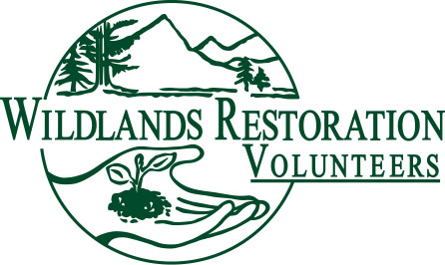
WRV Volunteer Role Description

Title: Agency Contact

Team or Committee Affiliation: Project team member

Description: On projects this individual is the primary point of contact with the sponsor agency. The Agency Contact (AC) is normally a staff person employed by the sponsoring agency.

Objectives: The AC communicates the desires of agency to the project team, negotiates the project scope, and coordinates the provision of agency services necessary for the implementation of the project.

Responsibilities: Be the liaison between the agency and WRV. Work closely with the Project Leader (PL) and Technical Advisor (TA) to insure the success of the project. The AC contact must communicate all project expectations to PL and TA. The AC negotiates the project memorandum of understanding (MOU) with the PL. Helps coordinate project safety and the provision of emergency service on project day.

Background or qualifications: Appointed by the sponsor agency with authority to make decisions concerning proposed WRV project. Have the necessary time in their schedule to coordinate the project with WRV.

Training/Preparation: Should be comfortable working with volunteers. Should understand what needs to be accomplished for the project to be a success.

Time/Place: The AC needs to be available to meet with the team and coordinate a site visit. The AC needs to meet with the PL and TA as needed to define the expectations for the project. This can normally be accomplished through a site visit, but additional meetings may be necessary if the project is complicated or technical. The AC should be available the day of the project.

Length of Commitment: For the duration of the project

Over-sight: The AC works directly with the PL and TA to ensure the success of the project.

Measures of success: The completion of a high quality project that meets the mission of WRV and meets the expectations of the sponsoring agency.

