
Campbell Valley Restoration
Crew Leader Notes

Overview
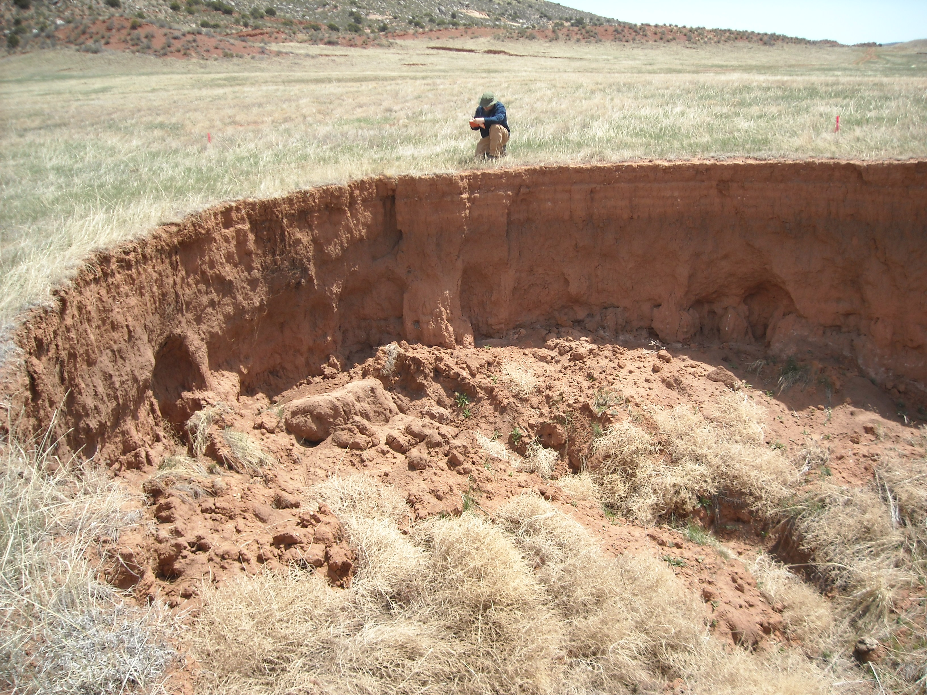
History Campbell Valley lies about 30 miles north of Fort Collins in one of the most important foothills-plains transition zones in the Front Range. This is a fascinating, historic, large private ranch that is subject to a conservation easement by The Nature Conservancy. In the early 1900's, the North Poudre Irrigation Canal breached, flooding Spring Gulch, the primary spring-fed creek in the Campbell Valley. The elevation of the creek was down-cut by as much as 40 feet, causing the elevation of most of the valley tributaries to drop commensurately (tributary rejuvenation). This massive change in the watershed has caused head-cutting and down-cutting of every tributary in the valley, resulting in the estimated loss of over 4,500,000 (that's right, Million) cubic yards of sediment. Gullies range from 5 to 30 feet deep and run up to 1,000 feet long. The riparian shrubland and forest that once existed along the creek has been replaced by a much simpler and less biologically diverse wet meadow.
This project is part of a long-term, valley-wide restoration plan that involves multiple partners and which will support improved grazing management practices with strategically placed, hardened water gaps and fencing; restores the diverse riparian shrubland and forest plant communities, and stabilize and heal the existing gullies. This is a multi-phase and multi-year restoration program.

We will be working in the former spillway from Evan’s Reservoir. It breached in the mid-80s and began headcutting toward the reservoir. In 2012 the dam was removed, and the reservoir converted to a wetland. The flow was diverted from the rapidly eroding spillway to its natural channel. Now we are working to help this landscape stabilize and revegetate.

Details

Location Evan’s Spillway and Leaky Creek in the Campbell Valley
Meet at the Livermore Community Hall and carpool to site

Schedule Sunday, March 31, 2019 9:00 – 4:00. See training schedule for greater detail.

Personnel
The project will have approximately 35 volunteers for 1 day. Leadership personnel are as follows:

First Name | Last Name | Role
Lynn | Morales | Crew Leader Instructor
Heather | McGee | Crew Leader Instructor
Rhonda | Rankin | Crew Leader Instructor
Phil | Rowe | Crew Leader Instructor
Mick | Syzek | Project Leader
Pedro | Lopez | Technical Advisor
Robert | Van Dopp | Tool Manager
Annemarie | Fussel | WRV Staff Liaison
Zach | Thode | Agency Staff

Site Map
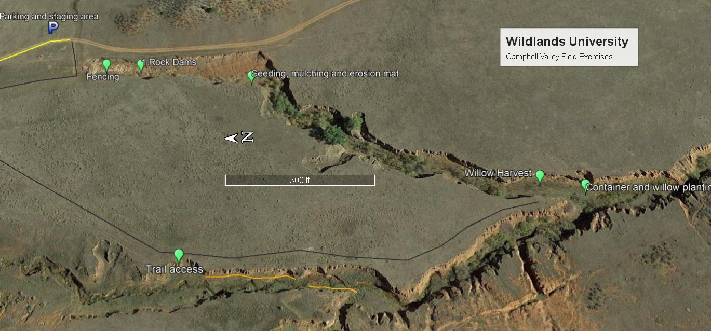

Safety

The terrain is flat, heavily vegetated, and usually close to water or marsh. The safety issues relevant to the site are given below.
- Barbed wire: This is cattle country. Barbed wire can be anywhere. Have your crew members be alert at all times.
- Uneven terrain, tires, and “cow” holes: Walk mindfully. It’s pretty easy to twist an ankle out there, and stepping in a hole could cause a broken bone or ligament/tendon damage in the ankle or knee.
- Working in mud and water along stream banks: It would be easy to twist an ankle or fall on a tool while working on the stream banks or in mud.
- Rattlesnakes: Pay particular attention in rocky areas and livestock trails (open areas) where the snakes may be sunning themselves.
- Heat exhaustion and sunburn: The site will be exposed to direct sun with little shade available. Encourage your volunteers to drink plenty of fluids and be aware of sunburn and overheating. Make sure crew members pace themselves. Crew leaders should constantly monitor their crews for signs of heat exhaustion (light-headedness or dizzy) and remind volunteers to drink fluids, take frequent breaks, and use sunscreen.
- Lightning: There is a chance for thunderstorms any time in the plains. We will be relatively close to our vehicles. So, if thunderstorms develop, head to the safety of the vehicles. Remember to keep 30 feet of space between volunteers as you head to the vehicles.
- Tool Use: Of course, improper use of tools poses a threat to the safety of crew members. Crew leaders need to explain proper use and transportation of tools at the beginning of the work day.

Communication

Each Crew Leader will be issued a talk-about radio. We will be working fairly close together, so radio communication should be feasible. Cell phone reception is spotty.

Incidents and Injuries See WRV Emergency Response Plan

The following steps will be taken by WRV Team Members in the event of an emergency.
- The project medic, or the person on the crew who has the highest level of appropriate emergency medical experience, will determine if emergency medical services are necessary. - If off-site emergency medical services are necessary, the project medic will contact Nate Boschmann (WRV Staff Liaison) who will contact emergency services (911) on his cell phone. For all serious injuries, please ensure that an Incident Report Form is completed.

Who communicates with emergency personal during an emergency?
The Project Medic is responsible for communicating with emergency personnel or delegating that responsibility as they see fit.

What is the plan for supervising the remaining volunteers while treatment/assistance is being rendered? The Crew Leader will manage the crew as necessary to reduce chaos during the emergency event and reduce the likelihood of another volunteer getting injured. As long as there isn’t an ongoing threat to other volunteers, volunteers should be encouraged to continue their work at a suitable distance away from the emergency scene.

WORK DESCRIPTION

Work will consist of three types of tasks:

- Seeding and mulching/erosion mat installation.
- Container stock planting and willow transplanting.
- Rock erosion control structures
- (optional) fence repair

Seeding and mulching/erosion mat

Seeding and soil amendment
- Prep soil by breaking large clods and evening out the soil surface.
- Apply biosol at the rate of 12lbs/1000ft2. 4lbs is indicated on the calibrated seeding bucket by the red tape.
- Apply seed mix at the rate indicated by the green tape for 500ft²on the calibrated buckets.
- Rake surface again lightly to incorporate the seed and biosol

Species (Common Name) | % Mix (desired)
Achillea lanulosa (Western yarrow) or millifolium | 5.00
Buchloe dactyloides (buffalo grass) | 15.00
Bouteloua gracile (blue grama) | 10.00
Elymus trachycaulus (slender wheatgrass) | 15.00
Elymus canadensis (Canada wildrye) | 10.00
Helianthus annuus (annual sunflower) | 5.00
Koeleria macrantha (junegrass) | 10.00
Oryzopsis hymenoides (indian ricegrass) | 10.00
Atriplex canescens (Fourwing Saltbush) | 5.00
Pascopyrum smithii (western wheatgrass) | 5.00

Erosion Mat

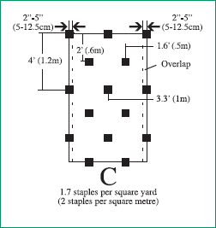
- Dig a trench for all external edges of the matted area. Overlap internal seams with the upper mat covering 6” of the lower unless otherwise instructed.
- Lay erosion mat vertically starting at the lower end of the section and working up.
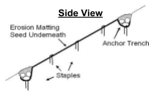
- Maintain good soil contact and fold and staple where necessary to conform to contours.
- Burry external sides of the mats in the trench and staple according to the diagram.

Wood Straw
- Where wood straw is indicated use 2 bales for every 200ft² section.
- Bales break apart into layers that are easy for one person to handle. Disperse layers around treatment area to facilitate even coverage.
- Wear long sleeves

Container Planting

The following table lists shrubs and trees that will be planted in the riparian area and the flagging colors used to designate their locations.

Common Name | Scientific Name | Flagging
Choke Cherry | Prunus verginiana | orange
Red Osier Dogwood | Cornus Sericea | blue
Buffalo Berry | Shepherdia argentea | green
Wood’s Rose | Rosa Woodsii | red
Wax Currant | Ribes cereum | Yellow yellow

Planting Instructions
First cut out the sod in the area you intend to dig a hole. Try to keep the sod intact as several large pieces to use in anchoring the weed barrier you install in the final step.
Dig a hole that is slightly deeper than the height of the soil containing the shrub to be planted. Make sure that the volume of the hole is about 50% larger that the volume of the shrub root mass. Thus, the hole needs to be wider and slightly deeper than the shrub.
As you remove the sod, keep it in football-sized chunks. It will be used later (flipped upside down) to create a burm around the transplant and hold down the weed barrier. Try to remove sod about 3-4 inches deep, and intact, rather than scraping off gradual layers of sod at a time.
When planted in the hole, the top of the soil in the pot should be at the same elevation as the adjacent soil next to the hole. If not, add or subtract soil.
Sometimes roots of the shrubs may have grown through the holes in the bottoms of the containers, making it difficult to remove the plants from the containers. If this is the case, you can remove roots protruding through the holes by pinching them off where the roots protrude from the holes. Avoid grabbing the plant by the stem and pulling forcefully from the pot. This can damage the plant or loosen the roots from the soil in the pot and stress the plant.
Place your hand palm down on the top of the pot, invert the pot, and carefully tap the bottom of the pot with your other hand to loosen the plant from the pot. Pull the pot away from the plant. Turn the plant right side up and place it in the hole. Tubes can be squeezed a few times to loosen plants.
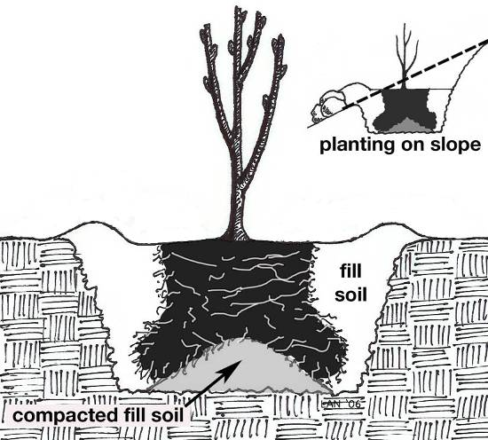
If the hole is too deep, you can place a little soil in the hole and move it under the plant until the top of the soil around the plant matches the elevation of the soil at the edge of the hole. If the hole is too shallow, carefully remove the plant from the hole and remove some soil from the hole, and place the plant in the hole again.
When the plant is properly positioned in the hole, backfill the hole with soil, making sure that there are no air spaces around the plant’s roots.
Compress the soil around the plant with your hands, or gently with your boot, to remove any remaining air pockets.
When the plant is happy in the ground, water each plant thoroughly. You can use a 5-gallon bucket to haul water from the stream. Crew members will need to haul water from nearby sections in some instances.
Install weed barrier around the base of the plant and anchor with staples and sod. Position the sod so that no loose edges of the weed barrier are exposed to the wind and a mini water/snow catchment is created.

Willow/Cottonwood Harvesting

Coyote willow is a fast growing disturbance-adapted willow that provides habitat for rodents and birds, and forage for deer and other large herbivores. The plains cottonwoods (Populus deltoides) provide a high canopy to help create “structural diversity” in this riparian area. Such structural diversity (a variety of shrub and tree canopy heights) is an important key to restoring habitat for a great diversity of wildlife in riparian areas.

Before we begin planting, it may be necessary to send one or more teams to harvest willows. Below are some guidelines for the successful harvesting of willows.

Selecting the Right Willows and Willow Stems
- Choose healthy stems (i.e., “green” wood in cross section) that are: relatively straight, covered in smooth bark (i.e., not furrowed or damaged), and free of insect/pathogen damage.
- Follow ethical harvest guidelines to conserve health of the donor stand:
- Remove no more than 1/3rd of the branches from any single willow.
- Never remove more than 40% of the overall willow canopy cover.
- Harvest stems evenly through the stand (e.g., not from one side of the willow only).

Harvesting and Preparation of Willow Cuttings
1. Harvest willow cuttings during the dormant season (between leaf fall and bud break):
- Select stems ½ to ¾ inches in diameter. In general, smaller diameter cuttings are appropriate for shrub willows (i.e., Salix exigua, sandbar willow), and even for some tree willows (i.e., Salix amygdaloides, peachleaf willow).
- Cut stems to length, as determined by specific project needs (e.g., depth to late-summer water table, severity of erosion and flood damage). Cuttings should be 6 feet long. Remove the cutting with a clean diagonal cut at the base of the stem. The diagonal cut is used to differentiate the rooting-end from the above ground end, and to aid installation.
- Prepare cuttings. Do NOT clip the terminal bud until they are installed, then trim to length, keeping at least two feet above the soils surface. At harvest site, remove all lateral (i.e., side) branches along the stem, as close to the stem as possible. Use caution and avoid damaging the stem while clipping the lateral branches. Removing lateral branches helps maintain an appropriate root-to-shoot ratio, reduces transpiration, and creates a cutting that is easier to install. Cut the top end of the stem horizontally to create a flat pounding surface if necessary.

Willow and Cottonwood Planting

- Water is critical. Pay close attention to planting depth and other planting guidelines designed to ensure natural subirrigation and surface irrigation of plants.
- Due to potentially difficult soils, cottonwood cuttings will need to be backfilled with loose soil from a borrow pit. (backfill will be provide at worksites). A loose slurry should be used to backfill the holes to ensure proper soil contact with the stem of cutting. Depending on how wet the hole is where you are planting, a slurry may be made by simply adding dry soil to the hole and mixing. If the hole is drier (i.e., you don’t hear or see water at the bottom of the hole), then you may need to mix dry soil with water first, and then add it to the hole.
- Willow and cottonwood cuttings have been pre-trimmed and staged nearby.
- Leave tops of cottonwoods un-trimmed. We want them to grow up vertically.
- Cut the top buds off willow stakes. We want them to branch out. Once installed, willow top should be at least two feet above the ground. Cottonwoods, once installed, should be at least three feet above the ground, but no more than five feet tall. If they are too tall, wind causes damage and there is too much distance from the new roots to the new shoots for water to be conducted up through the stem.
- A willow probe (tool with stake and T-handle) will be
used to help plant willows. Pre-dug augur holes will
be made for cottonwoods. Extra care should be made to ensure willows are inserted as far as possible to reach the groundwater. See diagram below on proper willow installation depth and finishing.

Rock Erosion control structures

A One Rock Dam “ORD” is a low grade control structure Developed by Bill Zeedyk. It’s constructed with a single layer of rock on the bed of the channel. ORDs stabilize the bed of the channel by slowing the flow of water, increasing roughness, recruiting vegetation, capturing sediment, and gradually raising the bed level.

- Dig a shallow footer trench and fill with one or two rows of rocks, so tht no rock protrudes more than 2 in above the bed of the channel.
- Scatter native seeds in the area where the ORD is to be built.
- Start building at the footer and continue upstream, laying down one layer of rock horizontally, as if you were building a rock wall on its side.
- Additional layers can be added after the ORD has filled with sediment.

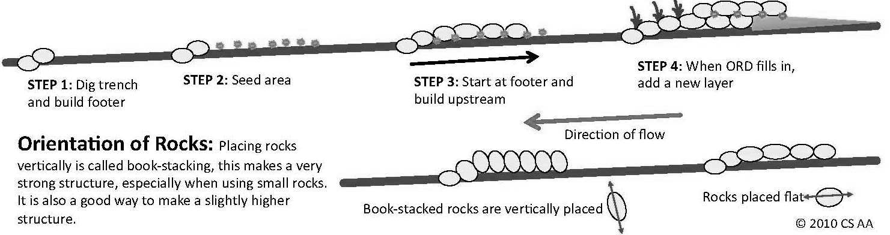

Barbed Wire Fencing

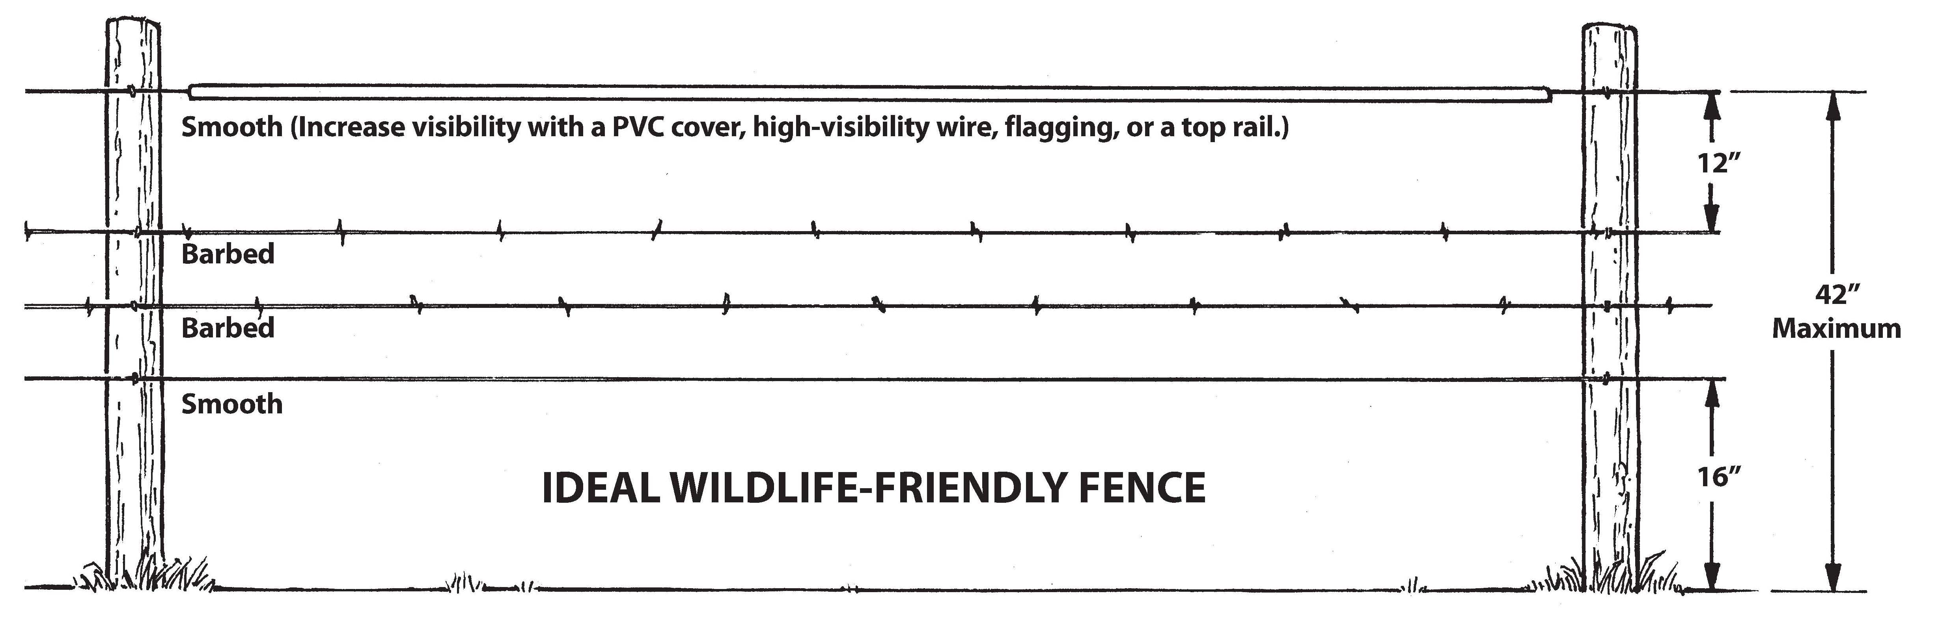
We will construct wildlife safe fence on all WRV projects. See the diagram below:
We will not be using any kind of cover on the top wire in this application. A line post should be installed a minimum every 15 feet with at least one twist stay between the posts. T–posts are commonly uses for this but it is good practice to install a wooden post every 100ft
Braces
Specs require that H-braces be installed every ¼ mile, but none of our fence runs will exceed that, so the majority of what we will be installing will be corner braces, These are two H-braces that share a common end post in order for the fence to change direction. See below for H-brace specs.
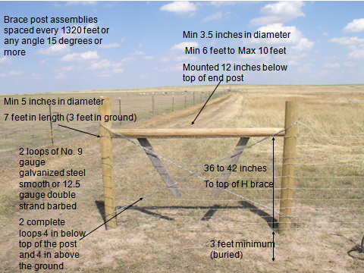
Between the H-braces

TOOLS LIST PER CREW (Instructors plus 5 volunteers)

5 | Planting and Transplanting |  |  | 5 | Seed and mulch |  |  | 2 | total
 | 2 | Loppers |  |  | 1 | Scissors |  |  | 4 | Loppers
 | 5 | Hand Pruners |  |  | 2 | Pick Mattock |  |  | 10 | Hand Pruners
 | 3 | Willow Probes |  |  | 2 | Spade shovel |  |  | 6 | Willow Probes
 | 5 | Safety Glasses |  |  | 3 | Single jack |  |  | 0 | Safety Gasses
 | 5 | Straps |  |  | 3 | Seed bucket |  |  | 10 | Straps
 | 3 | Planting shovel |  |  |  |  |  |  | 6 | Planting shovel
 | 2 | Bucket |  | 5 | Fencing |  |  |  | 4 | Bucket
 |  |  |  |  | 1 | Post pounder |  |  | 2 | Scissors
5 | Rock Structures |  |  |  | 1 | Post Stretcher |  |  | 6 | Pick Mattock
 | 1 | Wheelbarrow |  |  | 1 | Post puller |  |  | 4 | Spade shovel
 | 1 | Pick Mattock |  |  | 5 | Fencing pliers |  |  | 8 | Single jack
 | 1 | Shovel |  |  | 1 | Single Jack |  |  | 6 | Seed bucket
 | 2 | Mini pick |  |  | 1 | Canvas bag |  |  | 2 | Wheelbarrow
 | 2 | Canvas bags |  |  | 5 | Safety Glasses |  |  | 6 | Pick Mattock
 |  |  |  |  |  |  |  |  | 4 | Spade shovel
 |  |  |  |  |  |  |  |  | 4 | Mini pick
 |  |  |  |  |  |  |  |  | 4 | Canvas bags
 |  |  |  |  |  |  |  |  | 2 | Post pounder
 |  |  |  |  |  |  |  |  | 2 | Post Stretcher
 |  |  |  |  |  |  |  |  | 2 | Post puller
 |  |  |  |  |  |  |  |  | 10 | Fencing pliers
 |  |  |  |  |  |  |  |  | 8 | Single Jack
 |  |  |  |  |  |  |  |  | 2 | Canvas bag
 |  |  |  |  |  |  |  |  | 10 | Safety glasses

